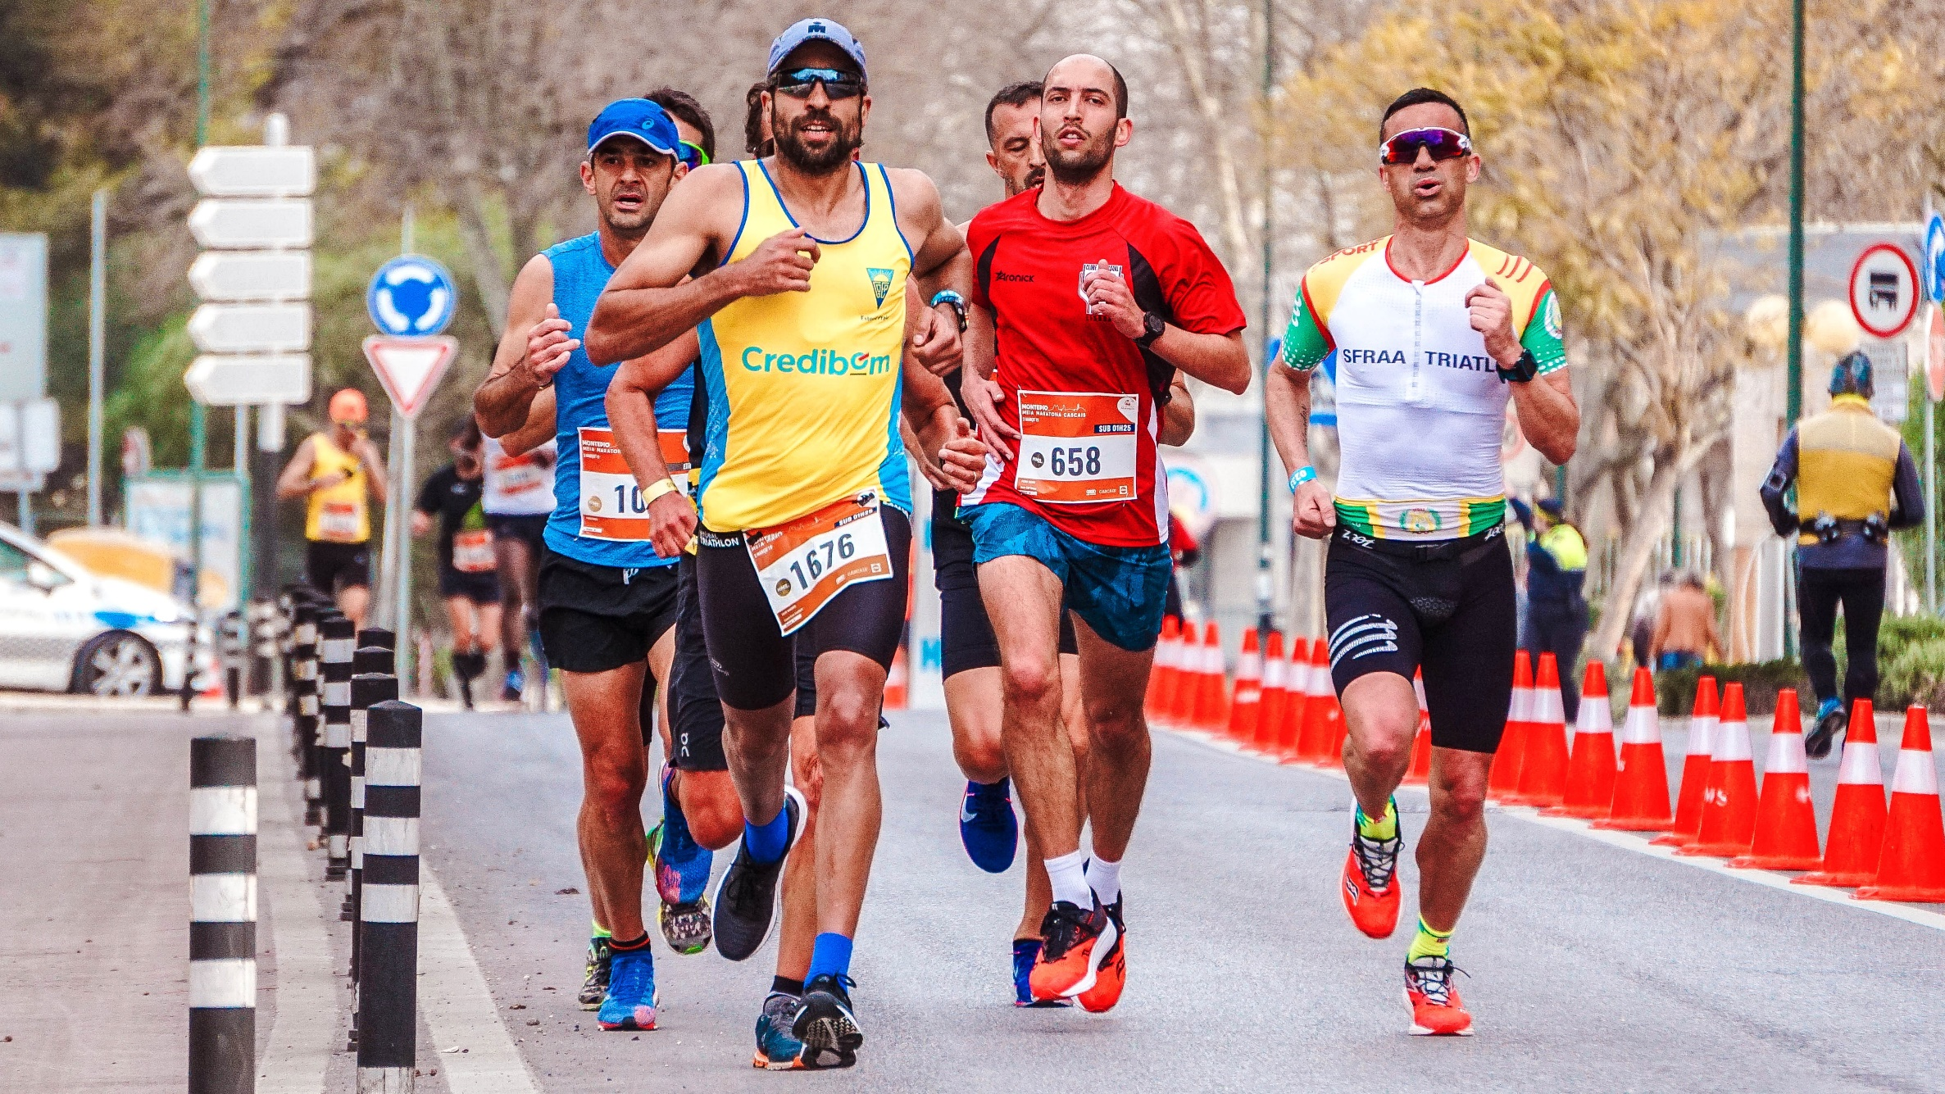

|  |
| --- |
| Sport Participation webserver & data analysis Interim report  Hdip Computer Science 2021 |
|  |
| February 3  SETU  Authored by: Sheila Kirwan |

# Abstract

# Acknowledgements

I would like to sincerely thank all the lecturing staff on the Hdip in Computer Science at South East Technological university for your guidance and enthusiasm throughout the course.

I would like to express my thanks to Brenda Mullaly, my project supervisor who provided great support throughout this project.

I would like to thank my husband Oliver and children, Robyn, and Oliver for providing a supportive environment for me to continue learning and growing.

# Preface

Write the preface at the end once the project is complete

# Table of Contents

Contents

Abstract 2

Acknowledgements 3

Preface 4

Table of Figures 6

Table of Tables 6

List of Abbreviations 6

appendices 6

Abstract 7

Project Proposal 8

Project Introduction 9

Methodology 10

Website methodology 10

Data Analysis methodology 11

Design 15

Screen Designs 15

Walkthrough 16

Data model 16

CLASS DIAGRAM 16

Project Timeline 17

Bibliography 19

# Table of Figures

Figure 1 13

Figure 2 13

# Table of Tables

# List of Abbreviations

# appendices

# Abstract

Researched how a data analyst can provide a portal for a customer to upload and view visualization

Decided on which tool to use. Streamlit with Python

Researched Data Analysis Tool, see list

Decided on which tools to use python using the pandas module, matplotlib, plotly, numpy, Jupyter notebook.

Ramp up phase began

Watched tutorial on python.

What were my main learnings

Watched tutorials on Streamlit

What were my main learnings.

Share all links in bibliography

Website Methodology (software engineering lifecycle)

Decided on website model.

iteration plans – show how the website evolved from one to multipage

Show Models here.

Screen designs

UML, Architectural Model, Process Flow Charts, Data Models (E-R), UI wireframes etc.

Data Analysis Methodology

Show model diagram here.

Walkthrough

Data model

reflection

# Project Introduction

The following interim report outlines my plan for the design and implementation of my project. My project will encompass both web design and data analysis with a high emphasis on data analysis and data visualization.

The customer for this project has a mass participation sports event company. This company organizes many races which can have many participants. Each Participant registers for an event online on their website.

The product of this project is a website that the customer can log into. This website includes user authentication. The website allows the customer to upload a .csv file is a predefined format. The website has many pages each of which provide customer insights and data visualizations using tables and graphs. The data insights provided were specified by the customer as the first steps in this project.

This project is python focused. The website is built using Streamlit which is an open-source Python library that makes it easy to create and share beautiful, custom web apps for machine learning and data science.

The tool and modules that I have selected and learned in order to complete the data analysis are as follows:

* Data Generator website
* Streamlit
* Python
* Pandas
* Matplotlib
* Plotly Express

Planning organizing and diagraming

* Penzu
* Trello
* Figma

IDE

* VSCode
* Jupiter Notebooks

From the project perspective, the main emphasis was on learning how to programmatically analyze data and programmatically create data visualization based on that data through the use of the python tools mentioned. This was of higher importance than the creation of the website created to host this however the creation of the website and selecting the most relevant tool to do so was also a task that proved interesting and useful.

# Methodology

This project is broken up into to two separate areas, including website creation and data analysis and visualization.

The overall project methodology applied to this project is the Agile Methodology.

The Agile Manifesto is as follows:

*We are uncovering better ways of developing  
software by doing it and helping others do it.  
Through this work we have come to value:*

*Individuals and interactions over processes and tools  
Working software over comprehensive documentation  
Customer collaboration over contract negotiation  
Responding to change over following a plan*

*That is, while there is value in the items on  
the right, we value the items on the left more.*

(Beck et al., 2019)

An agile methodology works well when the outcome of the project is unknown. As I have not previously studied any of the module’s, platforms and tools used for this project apart from python language which was part of the Hdip course content, this methodology was a good fit.

The following was the main benefit during this project of working with an agile philosophy

* Ability to manage changing priorities
  + At the beginning of this project, in order decide on a course of action to complete the project proposal website with data visualization, it was necessary for me to ramp up on all of the tools available to me. I began the process with a totally different plan to the plan that I later settled on. A lot of research of these areas and liaising with my supervisor who has experience in data analysis altered my trajectory to the current one.

Within the Agile Methodology, I choose to implement the Scrum Methodology. This methodology was well suited to my chosen project it allows a project to be completed in smaller increments at a time, with continuous experimentation and feedback loops to allow me to improve my project as I progress.

I incorporated scrum events such as Sprints to my planning process. I assessed the timeline available for completion of the project and set up 5 two-week sprint periods.

1. Jan 16 – Jan 29 – Develop website
2. Jan 30 – Feb 12 – Develop website
3. Feb 13 – Feb 26 – Data Analysis and Data Visualization
4. Feb 27 – Mar 12 – Data Analysis and Data Visualization
5. Mar 13 – Mar 26 – Fixes

The following table is my original project timeline plan which moved regularly during the agile process:

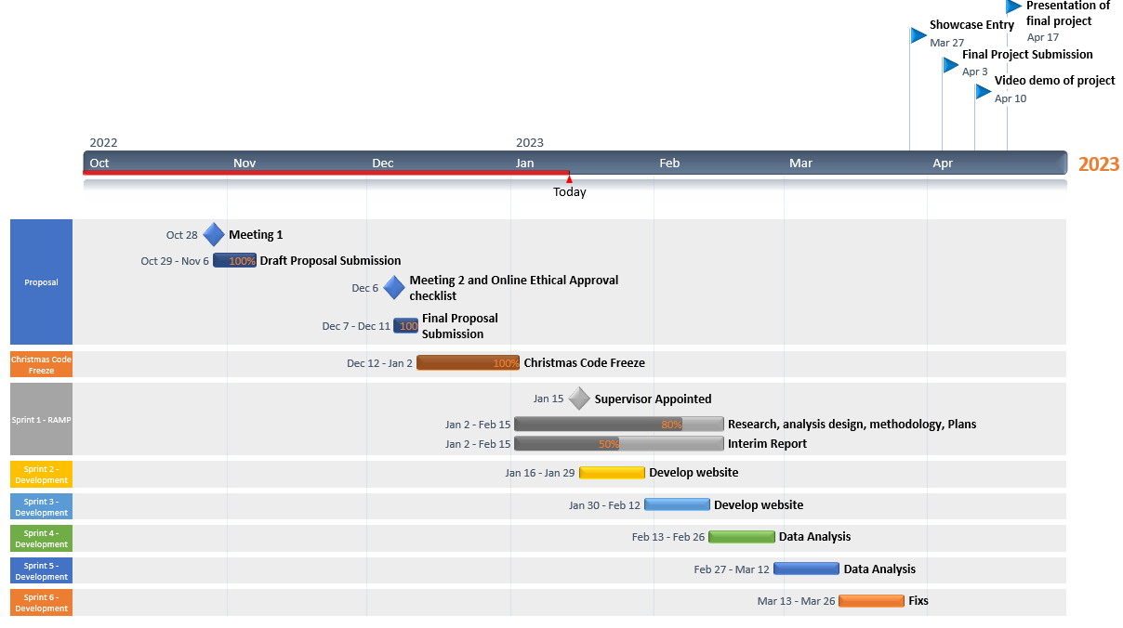

Figure

As part of the product backlog required in scrum methodology. I used the Trello as an agile tool to track tasks.

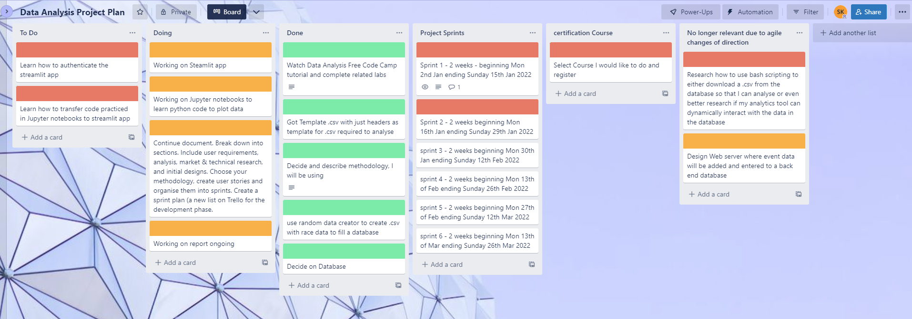

Figure

Finally, another tool that I employed throughout the project was the simple Penzu online Journal to track my work and provide a record of my decision making processes throughout the project timeline.

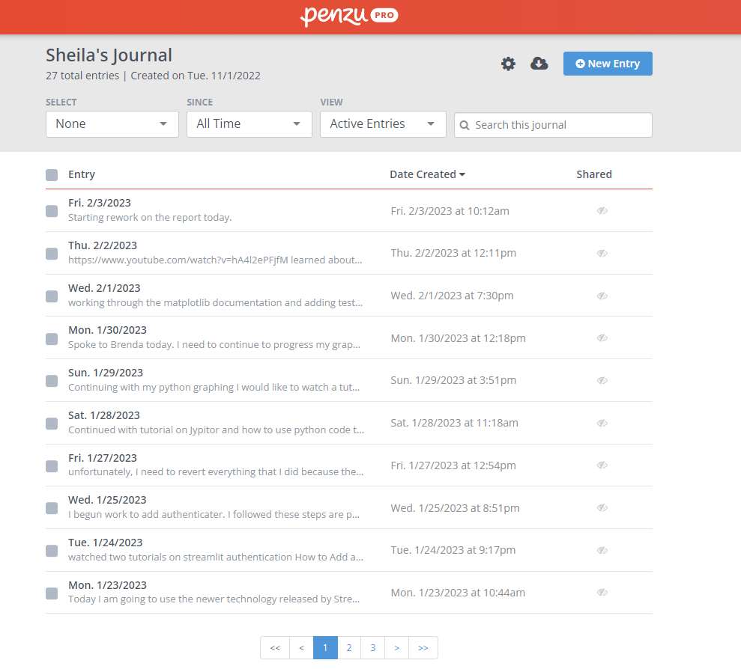

Figure

A very important first step as part of the development of this website with Data Analysis was ramping up on the possible portals, modules and processes which could be used to implement this project.

## Research and Analysis of prospective tools

Website process

Initially, I planned on building a website using the following, Node Framework, Hapi Framework and following the Model View Controller (MVC) architectural pattern. The original website was to employ Joi validation, Bulma, font Awesome and be deployed to Heroku. As part of my agile methodology, I decided that the use of these technologies for my data analysis project were not suitable for the following reasons.

* To build this website within the timeline would mean that my project would be a mainly a web development project rather than centered on Data Analysis.
* These tools were not specifically targeted at Data Analysts

This was my original website model.

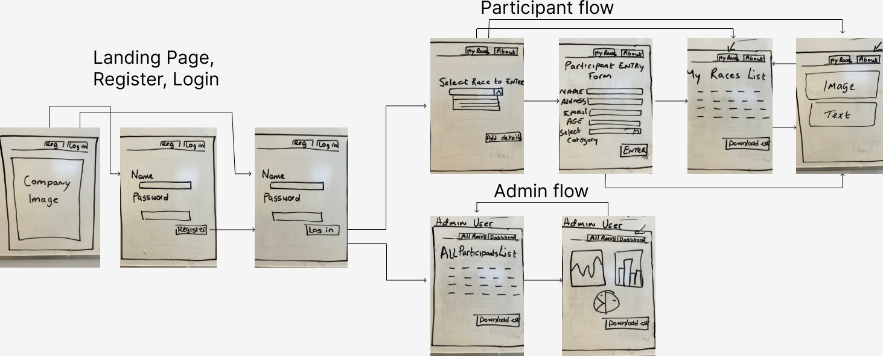

Figure

Instead after much research, I decided to use Streamlit to build my data analysis website.

Streamlit is an open-source python based dashboarding tool. It facilitates the creation and sharing of custom web apps for machine learning and data science. (docs.streamlit.io, n.d.)

Moving data science models from a Proof-Of-Concept (POC) in some notebooks (Jupiter notebook) to a Minimal Viable Product (MVP) that provides business value can be a tough transition. (Willemsen, 2022)

This can have a multitude of reasons:

* The amount of engineering work required to get your model integrated into existing systems.
* The slow (or nonexistent) feedback cycle with your users, resulting in a very slow cycle time for the last few remaining tweaks that need to be done.
* Lack of trust by your users in your model, resulting in your amazing model remaining unused.

Streamlit is tool which can be incorporated to reduce these impacts

In this case, the trade off between integrating the data analysis into a node based web app which would involve a lot of front end work or the into a Streamlit dashboard was the right choice for this project.

The benefits of using Streamlit for this project.

* Streamlit is not studied as part of the Hdip and hence was new learning
* Streamlit tool can be used for data analysis type websites
* Developing the web app using the python based Streamlit app is quicker than traditional web development tools
* Streamlit is Python based which means I can apply the programming knowledge that I have learned from the Hdip in Computer Science course (SETU) to code in Streamlit.

Why not Flask or Django?

Django and Flask are both well-known python-based web framework.

* The most significant benefit of using Streamlit as alternative to Flask is the ability to include HTML code inside the framework Python file. Streamlit does not involve different templates and CSS formatting for the front-end UI.
* The speed of development with Streamlit is faster than with Django.

Installation of Streamlit

Step 1. I created a folder on my windows 11 computer and installed Python

Step 2. Next, I used the command *pip install Streamlit* to install the Streamlit library.

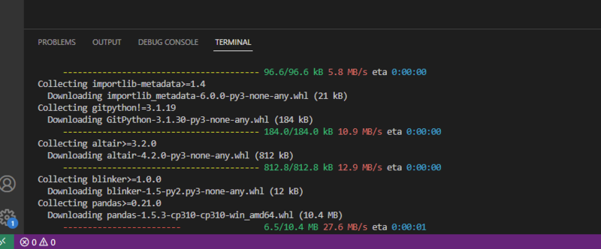

Figure

Step 3. I followed instructions in the Streamlit documentation for installation prerequisites (docs.streamlit.io, n.d.)

<https://docs.streamlit.io/library/get-started/installation#prerequisites>

Step 4. I set up virtual environment to run the following commands. I did this by running a PowerShell script (firstly setting the environment to where I will be creating my project folder)

Step 5. I ran the command *pip install virtualenv* to create a virtual environment

Step 6. I then created my project folder at this location and created a new folder within it called Streamlit.

Step 7. I then moved to this folder *cd streamlit* where I then ran the command virtualenv steamlitenv

Step 8. From that project path run the following command to activate the streamlitenv

C:\Users\User\PythonFinalProject\streamlit project>\Scripts\activate

This activated the new environment live with this response on the terminal

(streamlitenv) PS C:\Users\User\PythonFinalProject\streamlit project>

Step 8. I then installed the Streamlit within this environment.

(streamlitenv) PS C:\Users\User\PythonFinalProject\streamlit project> pip install streamlit

This took a few moments to install.

Step 9. To test, type the command *streamlit hello.* This will automatically open streamlit page in the chrome browser

As an aside, I ran into an issue running scripts on Windows and followed the following steps to resolve it by enabling the execution on windows to allow me to run scripts. This is something that I will revert for security reasons.

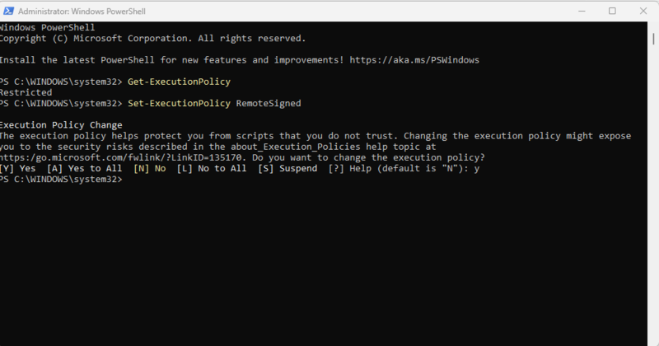

This is an example of how Steamlit appears in VScode

Methodology for preparing data file for analysis

Data Analysis Tools

Researched how a data analyst can provide a portal for a customer to upload and view visualization

Decided on which tool to use. Streamlit with Python

Researched Data Analysis Tool, see list

Decided on which tools to use python using the pandas module, matplotlib, plotly, numpy, Jupyter notebook.

Ramp up phase began

Watched tutorial on python.

What were my main learnings

Watched tutorials on Streamlit

What were my main learnings.

## Website methodology

## Data Analysis methodology

The following is research which I undertook in order to understand the data analysis tool options available to me for this project:

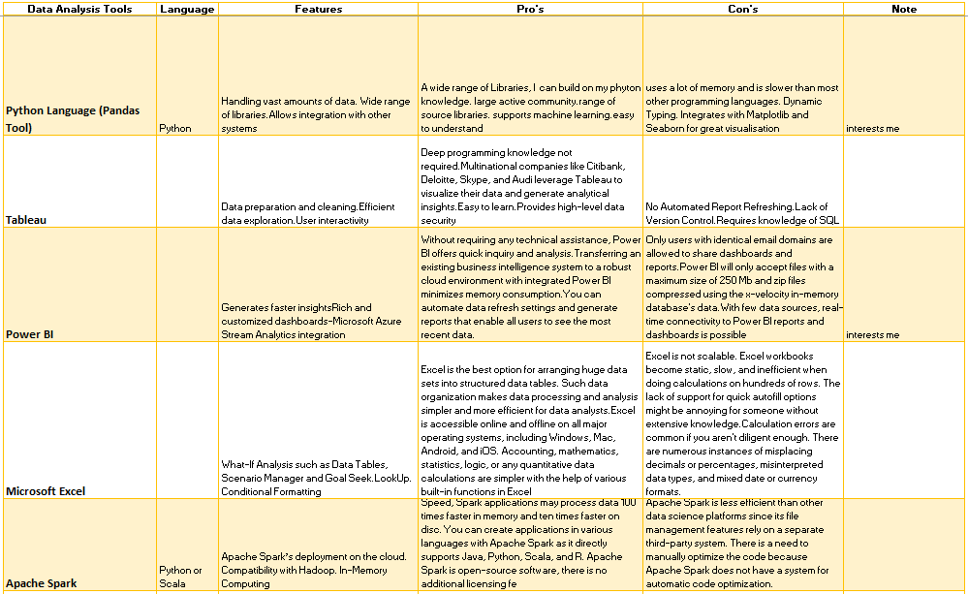

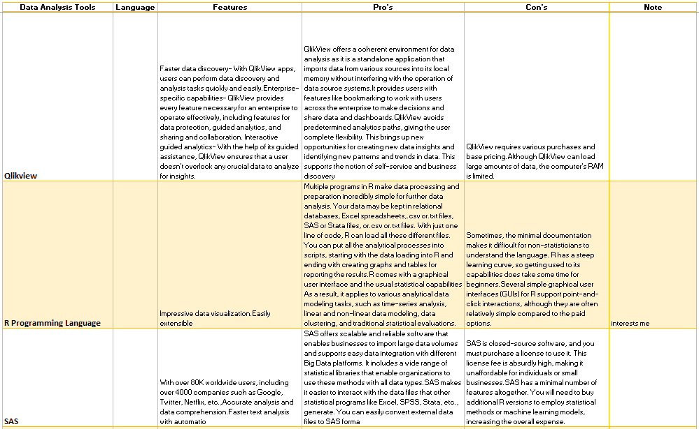

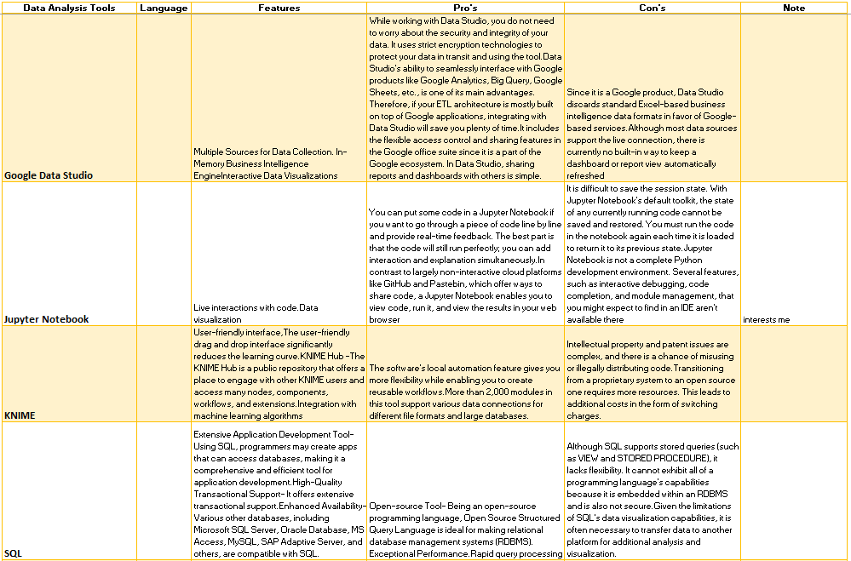

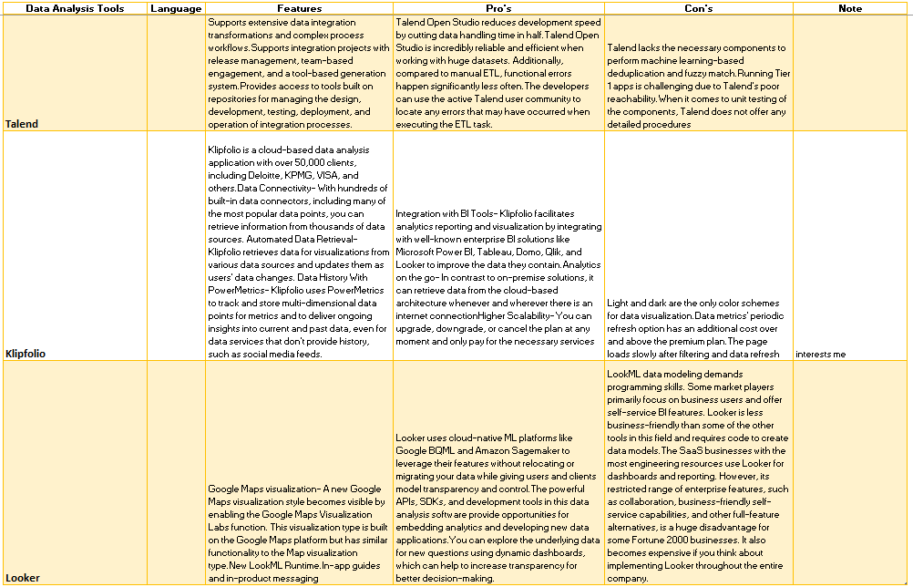

Reference: https://www.projectpro.io/article/data-analysis-tools/607#mcetoc_1g96olmfr4q

Based on the research undertaken, I selected to use Python. The reasons are as follows:

|  |
| --- |
| 1. Requires Programming Knowledge |
| 1. Python Library 'Pandas' make data manipulation easier |
| 1. Data Handling should be easy using the 'io' module |
| 1. Its Free and Open-source platform |
| 1. Data Analysis easier due to its simple syntax and built-in functions and libraries |
| 1. Data Visualizations provided by several excellent graphing libraries loaded with a wide range of capabilities |

Sample of Data for analysis in .csv file format



Preparation Tasks for Data Analysis as it is not a module of this hdip in computer Science:

Data Analysis tutorial (4 hours) which provided me with basis for data file analysis.

<https://www.youtube.com/watch?v=r-uOLxNrNk8&t=12290s>

# Design

## Screen Designs

Full website

* Log in (authentication)
* Upload file
* Select Data insights and visualizations on page

## Walkthrough

## Data model

### CLASS DIAGRAM

# Project Timeline

<https://www.officetimeline.com/office-timeline/14-days-trial#download-office-timeline1>

Meeting with my new superviser Brenda today.

Complete change of plan.

I will find a tool that can host a data analysis and allow an inputted file and includes data authentication.

<https://blog.streamlit.io/streamlit-authenticator-part-1-adding-an-authentication-component-to-your-app/>

<https://www.youtube.com/watch?v=HU_kd-1uIkQ>

<https://towardsdatascience.com/getting-started-with-streamlit-web-based-applications-626095135cb8> WATCH THIS ONE

Streamlit appears to be one such tool.

# Bibliography

There are no sources in the current document.

# Project Tools

[Creation of timeline plan - https://www.officetimeline.com/office-timeline/14-days-trial#download-office-timeline1](Creation%20of%20timeline%20plan%20-%20https://www.officetimeline.com/office-timeline/14-days-trial#download-office-timeline1)

DECLARATION OF AUTHENTICITY

I declare that all material presented to South East Technological University (SETU) is my own work, or fully and specifically acknowledged wherever adapted from other sources. I understand that if at any time it is shown that I have significantly misrepresent material presented to South East Technological University (SETU), and degree or credits awarded to me based on that material may be revoked.

|  |  |  |  |
| --- | --- | --- | --- |
| Student’s Signature |  | Date |  |
| Supervisor’s Signature |  | Date |  |